Advocacy Partners, LLC Date Received application: ______ Service…Commitment, Support, Dreams
3150 Carlisle NE, Suite 201
Albuquerque, NM 87110
Phone: (505) 872-2115, Fax: (505) 872-9490

All of the following documents must be current
 Copy of Current Driver’s License
 Copy of Social Security Card
 Copy of Vehicle Registration
 Copy of Vehicle Insurance
 Copy of any Training Certificates (Especially CPR/First Aid)
 Copy of Homeowners/ Renters Insurance (Only if applying for FLP/CHIS)
 Copy of Animal Vaccinations (Only if applying for FLP/CHIS)
 Certificate of Health (Only if applying for FLP/CHIS)
As a new provider, you will need to have your fingerprints taken and have a federal and statewide background check completed.
For more information or to make an appointment please call
The office at (505) (505) 872-2115.

APPLICATION INFORMATION

Position Applying for (Check all that applies):
FLP/ CHIS | Substitute Care | CCS | Respite | Office Employee

_________________________ _________________________ _________________________
First Name Full Middle Name Last Name

Address: ________________________________ City/State/ Zip: ________________________

E-Mail: _______________________________________________________________________

Cell Phone: _______________ Home Phone: _______________ Work Phone: ______________
PERSON TO CONTACT IN CASE OF EMERGENCY

Name: ___________________________________ Relationship: _________________________
Phone#: _____________________ Address: _________________________________________

OTHERS RESIDING IN HOME (For Family Living Providers only)

If anyone in the household 18 years of age or older must complete criminal history-screening
(Only complete if applying for FLP/CHIS)
Name | Relation | DOB

RECORD OF EDUCATION

(Include High School, University/ College, Trade, Business or Correspondence School)
School Name & Address | Course of Study | Years Completed | Did you Graduate? | Diploma/ Degree
Name:  Address:  City, State: |  | To:  From: | Yes ______  No ______
Name:  Address:  City, State: |  | To:  From: | Yes ______  No ______

EMPLOYMENT HISTORY

All employers listed below will be requested to verify the information that you provide herein
Employer Name: ______________________________________ Phone # ________________
Address: ________________________________ City/State/Zip _______________________
Date of Employment (month/year): ___________ to ___________ Salary: _______________
Position Held: __________________________ Supervisor: ___________________________
Job Duties: __________________________________________________________________
Reason for Leaving: ___________________________________________________________

Employer Name: ______________________________________ Phone # ________________
Address: ________________________________ City/State/Zip _______________________
Date of Employment (month/year): ___________ to ___________ Salary: _______________
Position Held: __________________________ Supervisor: ___________________________
Job Duties: __________________________________________________________________
Reason for Leaving: ___________________________________________________________

(I hereby authorize Advocacy Partners to contact the above listed employers to obtain information concerning my past employment history.)

_______________________________________________________ ____________________________________
Signature Date

MILITARY SERVICE RECORD

US Military Service: ______________________________________ Rank: ________________
Date of Service: ________________________ Honorable Discharge? Yes: ______ No: ______
National Guard or Reserves: __________________________ Date of Service: ______________
Honorable Discharge? Yes: ______ No: ______
CHARACTER REFERENCES

List three people; exclude relatives, whom we can contact by mail, telephone or in person to provide a character reference for you. Please list complete address.
Name | Years Know | Address | Phone#
Day#

Evening #
Day#

Evening #
Day#

Evening #
(I hereby authorize Advocacy Partners to contact the above listed individuals to obtain my personal and professional history for purpose of this pre-screening.)

_______________________________________________________ ____________________________________
Signature Date

CRIMINAL HISTORY

Have you ever been named in a complaint, arrested or received a felony conviction?
YES: _____________ NO: _____________

(I hereby authorize Advocacy Partners to obtain information concerning my past criminal history for the purpose of this pre-screening.)

_______________________________________________________ ____________________________________
Signature Date

(Past criminal history may disqualify you from providing services (29NMAC 17.2, New Mexico’s Caregivers Criminal History Screening Act. If you checked YES above, please enclose documentation about each situation. The CCHSP, DOH has the final authority to qualify or disqualify caregivers. If you disagree with their decision, you may request a reconsideration by calling 1-505-827-1417.)

HEALTH

Do you have a medical condition, mental illness or disability that would prevent you from providing support services to a person with disabilities? _____ Yes _____ No

_______________________________________________________ ____________________________________
Signature Date

VEHICLE INFORMATION

Main vehicle that will be used to transport the person receiving services:
Year: ________________ Make: ______________________ Model: _____________________
License No. ________________ Vehicle Identification No. _____________________________
Name of Registered Owner(s): ____________________________________________________
Insurance Company: ____________________________________________________________
(Please enclose copies of your vehicle registration and proof of car insurance.)

APPLICANT’S PERSONAL CERTIFICATION

I hereby certify that all of the information submitted by me on this application and any additional information that I have submitted to Advocacy Partners LLC. during this pre-screening process is true and complete. I understand that if any false information, omissions, or misrepresentations are discovered, I may be disqualified from continuing in the application process or, in the event I have entered into a contract or employment to provide services to Advocacy Partners LLC. my contract or employment will be terminated.

__________________________________________________ _______________________
Applicant’s Signature Date

DAYS | HOURS
Monday  | Day ( From: To: ) Night ( From: To: )
Tuesday  | Day ( From: To: ) Night ( From: To: )
Wednesday  | Day ( From: To: ) Night ( From: To: )
Thursday  | Day ( From: To: ) Night ( From: To: )
Friday  | Day ( From: To: ) Night ( From: To: )
Saturday  | Day ( From: To: ) Night ( From: To: )
Sunday  | Day ( From: To: ) Night ( From: To: )

Please circle YES or NO to the questions
Are you willing to provide Respite/ Substitute Care in your home? | YES | NO
If so, are you willing to have individual’s sleep over? | YES | NO
Would this individual have their own room where they could have privacy and their things would be safe? | YES | NO
Do you have pets?  If yes please list type(s): | YES | NO
Are you willing to stay over at the individual’s home? | YES | NO
Would you be willing to take individual’s to church of their choice, even if it is not your faith or belief? | YES | NO
Would you be willing to take two individual adults out on a date, if that is what they wanted to do? | YES | NO
Are you able to provide emergency respite or sub-care?  This might be respite/sub-care for some that you do not necessarily know but will be crossed trained on. | YES | NO
Are you interested in being a back-up respite or sub-care provider? | YES | NO
Are you interested in being a back-up CCSI/ CCSSG provider? | YES | NO
Are you willing to work with an individual with mobility issues, such as using wheelchairs, walkers, etc? | YES | NO
Are you able to assist an individual with transferring to and from a wheelchair? | YES | NO
Is your home wheelchair accessible? | YES | NO
Do you have a vehicle that has a wheelchair lift or is wheelchair accessible? | YES | NO
Are you willing to work with an individual that is hearing, communicatively and/or visually impaired? | YES | NO
Do you know sign language? | YES | NO
Are you bi-lingual?  If yes, please list what language(s): | YES | NO
Would you be willing to provide transportation for our individuals? | YES | NO
Is your vehicle dependable to transport individuals? | YES | NO
Do you have any individuals living in your home now?  Male or Female? | YES | NO
Are you able to complete all training? | YES | NO
Are you to lift at least 40 lbs.? | YES | NO

APPLICANT’S
AUTHORIZATION TO RELEASE INFORMATION

I understand that the Long-Term Services Division, Department of Health, has set certain policies pertaining to the home study process intended to assure that individuals receiving services live in settings with others who promote the individual’s capacity for independent functioning and productivity and in which the individual’s health and safety are assured. Therefore, I hereby authorize Advocacy Partners LLC. to request the following background information concerning me and authorize the following named entities or persons to release such information to Advocacy Partners LLC.

- An FBI background and fingerprints check from the New Mexico Department of Health Caregivers Criminal History Screening Program.
- Any New Mexico arrest fingerprints card supported record information maintained by the New Mexico Department of Public Safety (or similar agencies in other states where I have resided within the past years), including information concerning felony or misdemeanor arrests (an Authorization for Information is enclosed);
- A driver’s record check based upon my driving record maintained by the New Mexico Motor Vehicle Department (or similar agencies in other states where I have resided within the past years);
- Information about my personal and professional history provided by the person whose names and addresses I have listed above as character references or any former employers I have listed above;
- My medical record information was provided my healthcare provider; and
- Information provided by my adult children and/or at least one adult relative whose names and addresses I have listed in this application.

I understand that Advocacy Partners LLC. will not use any of the information above for any other purpose other than pre-screening and will comply with all provisions of the Fair Credit
Reporting Act, Public Law 91-508, the Americans with Disabilities Act (ADA 1990), and all other applicable Federal and State laws and regulations. All information obtained is for the exclusive use of Advocacy Partners except to disclose said information to me and in accordance with applicable law and the provisions and policies of the Medical Assistance Division of New Mexico Human Services Department, Medical Assistance Program Manual, Section MAD-736, and the contract between Advocacy Partners and the Long Term Services Division of the New Mexico Department of Health.

_______________________________________________________ _____________________
Applicant’s Signature Date

Advocacy Partners LLC.

FIREARMS AGREEMENT

I understand that the Long Term Services Division, Department of Health, has set certain policies pertaining to the home study process intended to assure that individuals receiving services live in settings that are safe. I understand that the acceptable means of securing weapons and ammunition are either with trigger locks or in locked closets, cabinets or drawers that are sturdy enough to resist a child or young adult’s efforts to open. I understand that storage units and locks should be checked periodically to ensure that they are still secure and/or have not been tampered with. I further understand that ammunition should be stored further than arm’s length from the weapon in a separate locked container.

I hereby certify that to prevent injury or death from accidental shooting, all firearms, and weapons, including, but not limited to, handguns, rifles and shotguns, bows and arrows, and pellet guns will be secured under lock and key at all times. All forms of ammunition will be stored separately from the weapons in a locked container that is located further than arm’s length from the weapon.

I understand and accept the responsibility that any failure to comply with firearm safety requirements may result in a termination of the contract with Advocacy Partners LLC. signed by either me or a member of my household. My signature below indicates that I understand and agree to comply with these firearm safety requirements.

Signature: ____________________________________________________________________

Please Print Name: _________________________________________ Date: _______________

Your Email Address: ________________________________ Phone: _(_____)______________

Name of Agency: ______________________________________________________________

Classes required
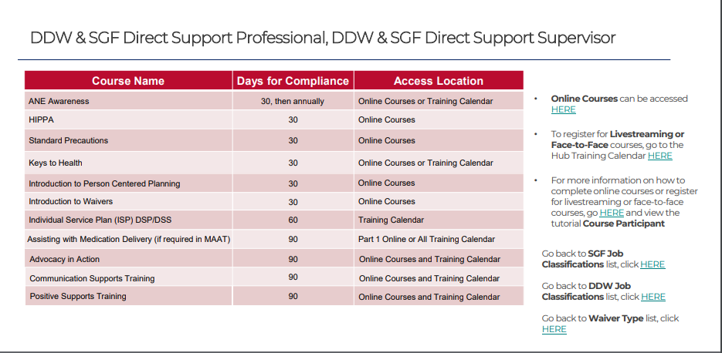
- AWMD (This class will need to be taken annually)
- Incident Reporting (ANE) (This class will need to be taken annually)
- First Aid & CPR is good for only TWO YEARS!

